Are younger people really more undemocratic?

Suggested author order: Olivier Bergeron Boutin, Dietlind Stolle, Elisabeth Gidengil (needs to be confirmed by input and work on actual article)

-->Some say younger generations]are getting more undemocratic. Others don't believe it, but evidence is thin

​Thin evidence includes:
--low correlations between different items that are supposed to measure support for democracy

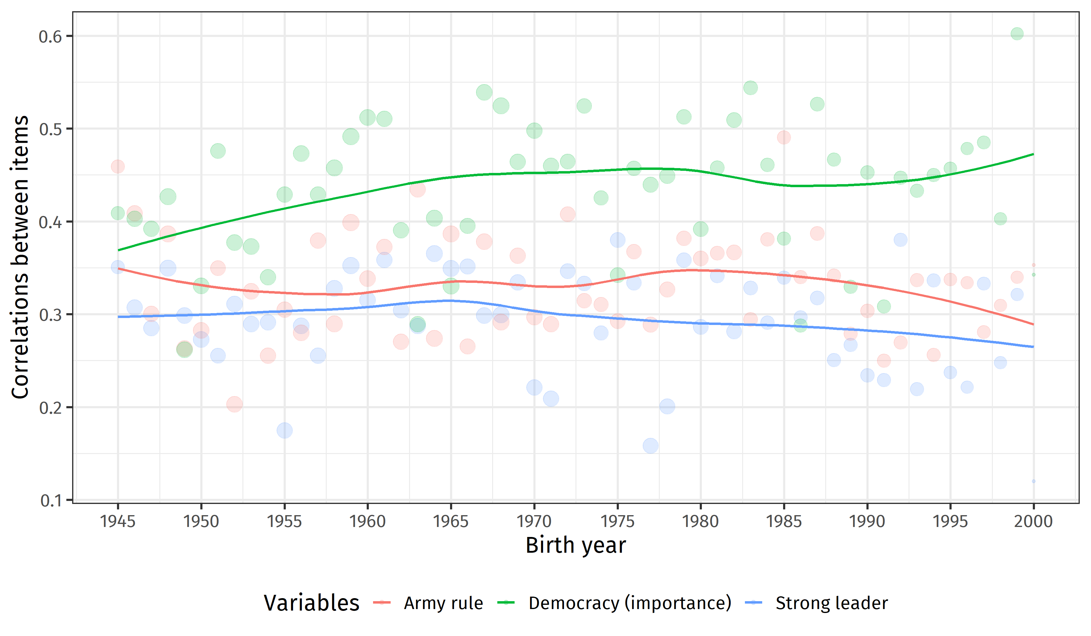

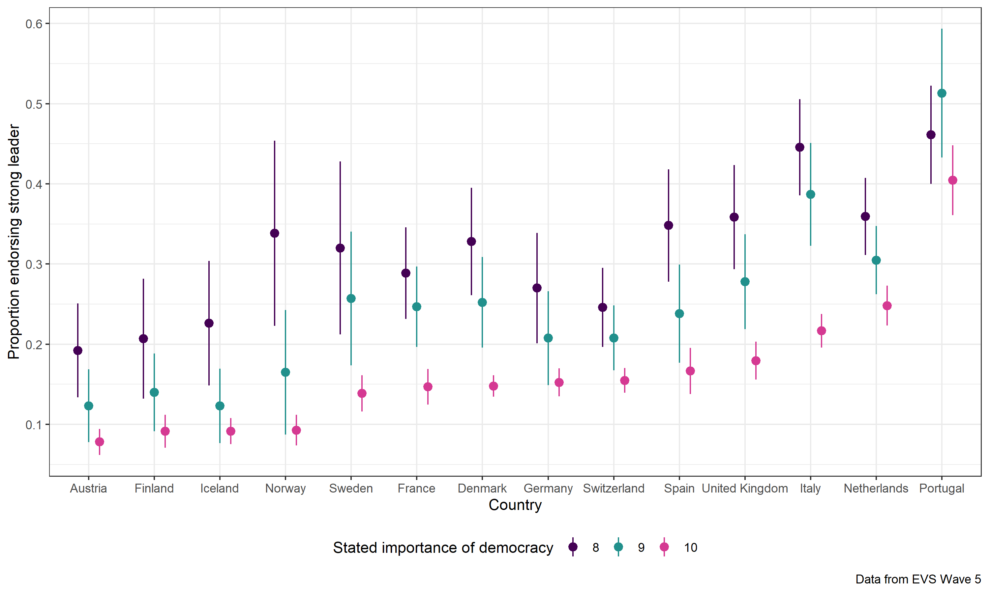

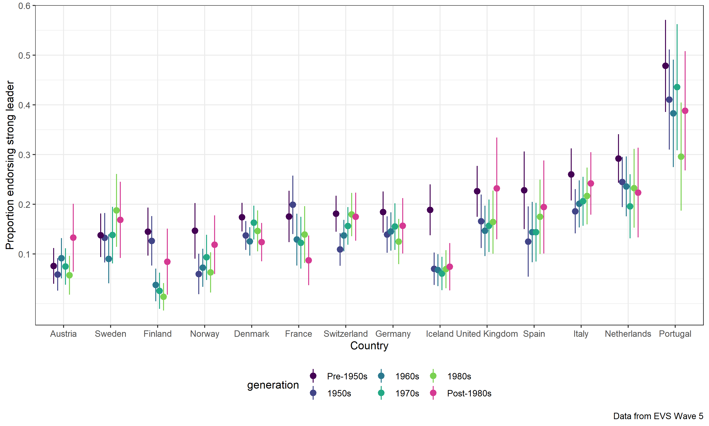

--but there is some evidence of a disenchantment when it comes to the "importance of democracy" question.
--That being said, differences across countries are generally much larger than within-country differences according to age.

See graph on democracy is important below

So, this presentation is trying to understand what’s behind young people paying less attention to democracy? Are they really against it and for authoritarian solutions (antipathy to democracy) or simply not aware (apathy). Or simply more critical citizens?

Some hypotheses:
1) Critical citizens: they are critical and not satisfied with how democracy is run and thus give bad marks to satisfaction but high marks to importance to democracy simultaneously. In this case we would need to do some analysis on where the ones dissatisfied with US democracy/Canadian democracy fall on our nominal measures and on our backsliding questions? See also Zilinsky.

2) No clarity on alternatives: Younger generations cannot easily distinguish between democracy and other alternatives. Potential reason: they did not grow up in the cold war, where world was divided into good democracy and evil communism.

3) Democracy versus actual scenarios: Younger generations care less about the concept of democracy but actually care and act differently when actual scenarios are being discussed (our vignette and scenario questions which exclude the word democracy but ask for actual situations)

4) Democratic Knowledge: Yong generations simply do not know about what’s democratic or what’s not, this could certainly be a life cycle effect but could also indicate a larger problem with less understanding about democracy (see also 2)

Alternative: Or we find evidence that taking all of these option into account still shows that younger generations score lower than older generations.

Evidence
Here are suggestions:
1) Critical Citizens: Here we need an analysis of how dissatisfaction with democracy is related to democratic support (importance)

- Show satisfaction by generation

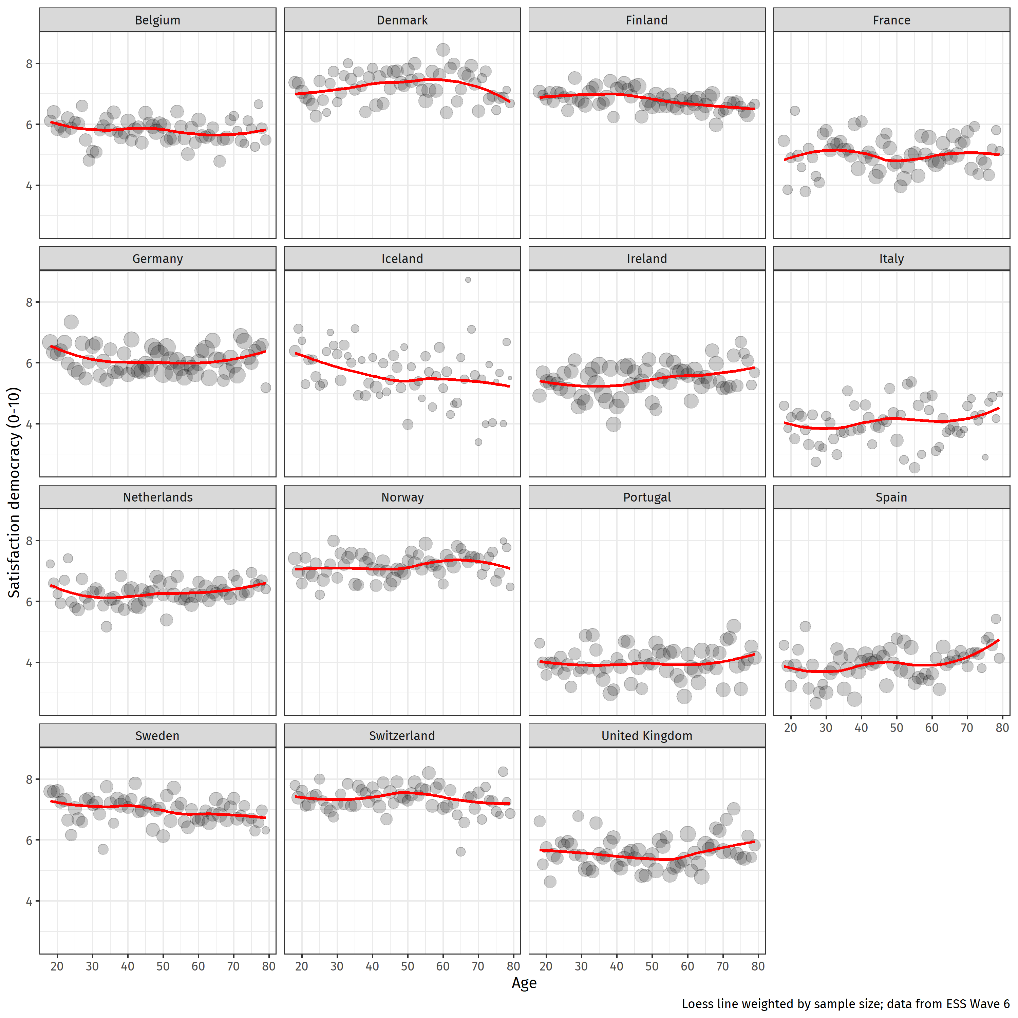

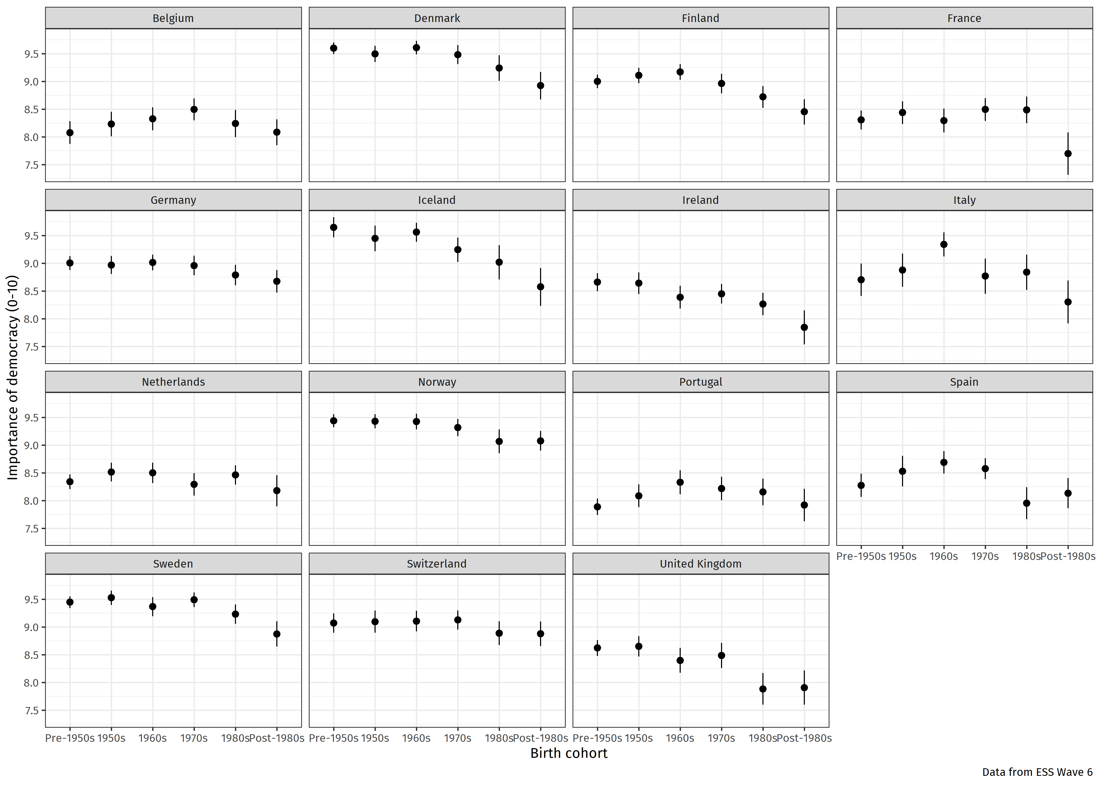
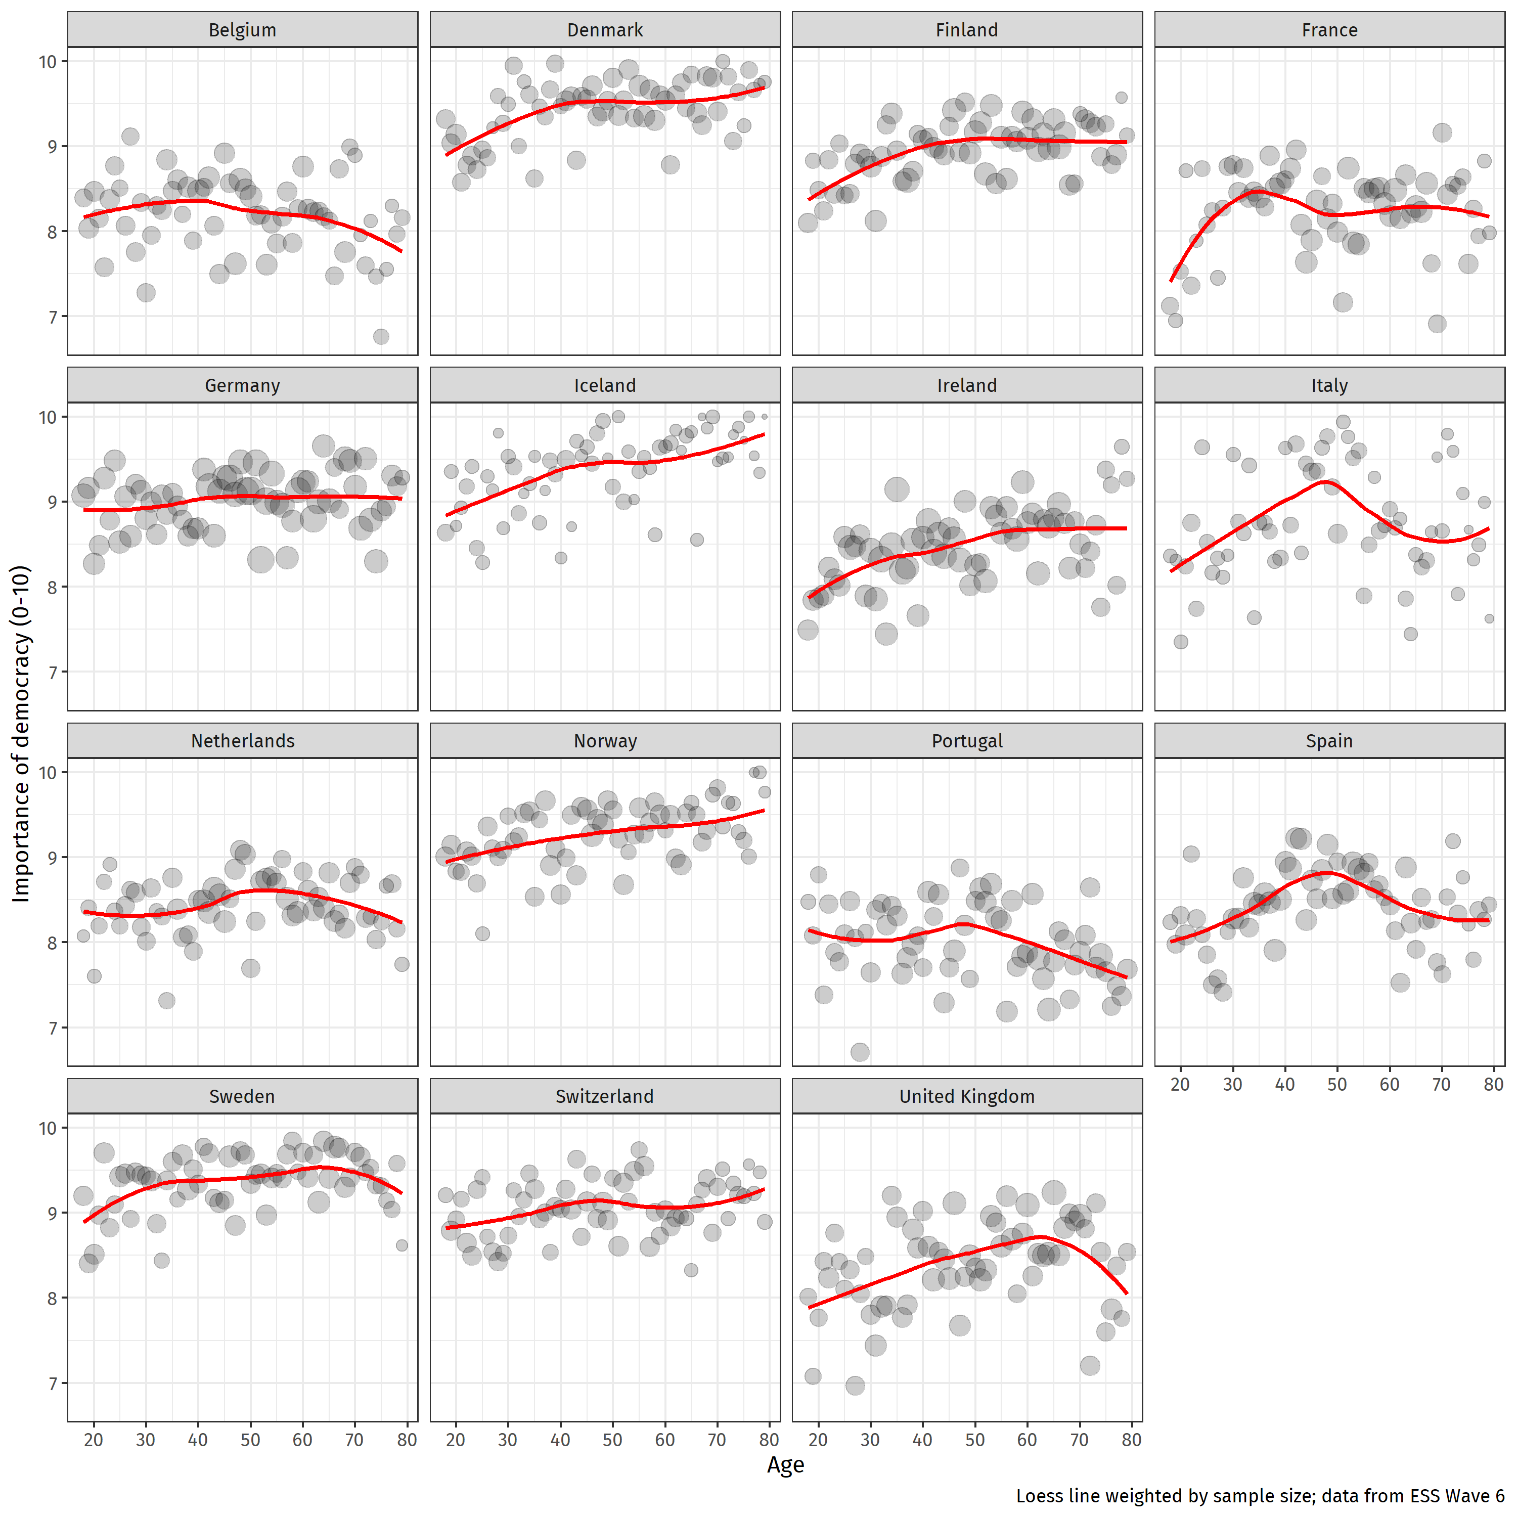

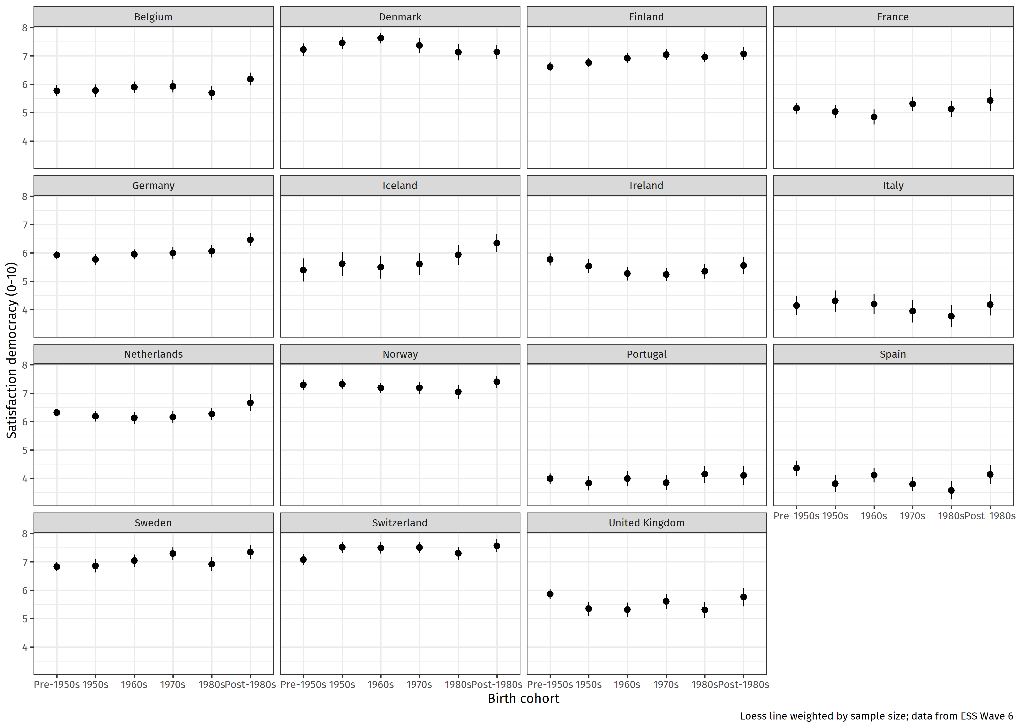
- Show satisfaction by importance and generation (see Appendix)

Output
- I divided the ESS data into 4 quartiles of satisfaction with democracy and plotted importance of democracy by generation. See Appendix. It looks like pretty much across the board, regardless of their satisfaction, younger generations rate democracy as less important. Again, the differences are not huge and overall ratings remain quite high, but the difference is there and it persists.
- show that satisfaction with democracy does not vary much across generations (at least in Europe).

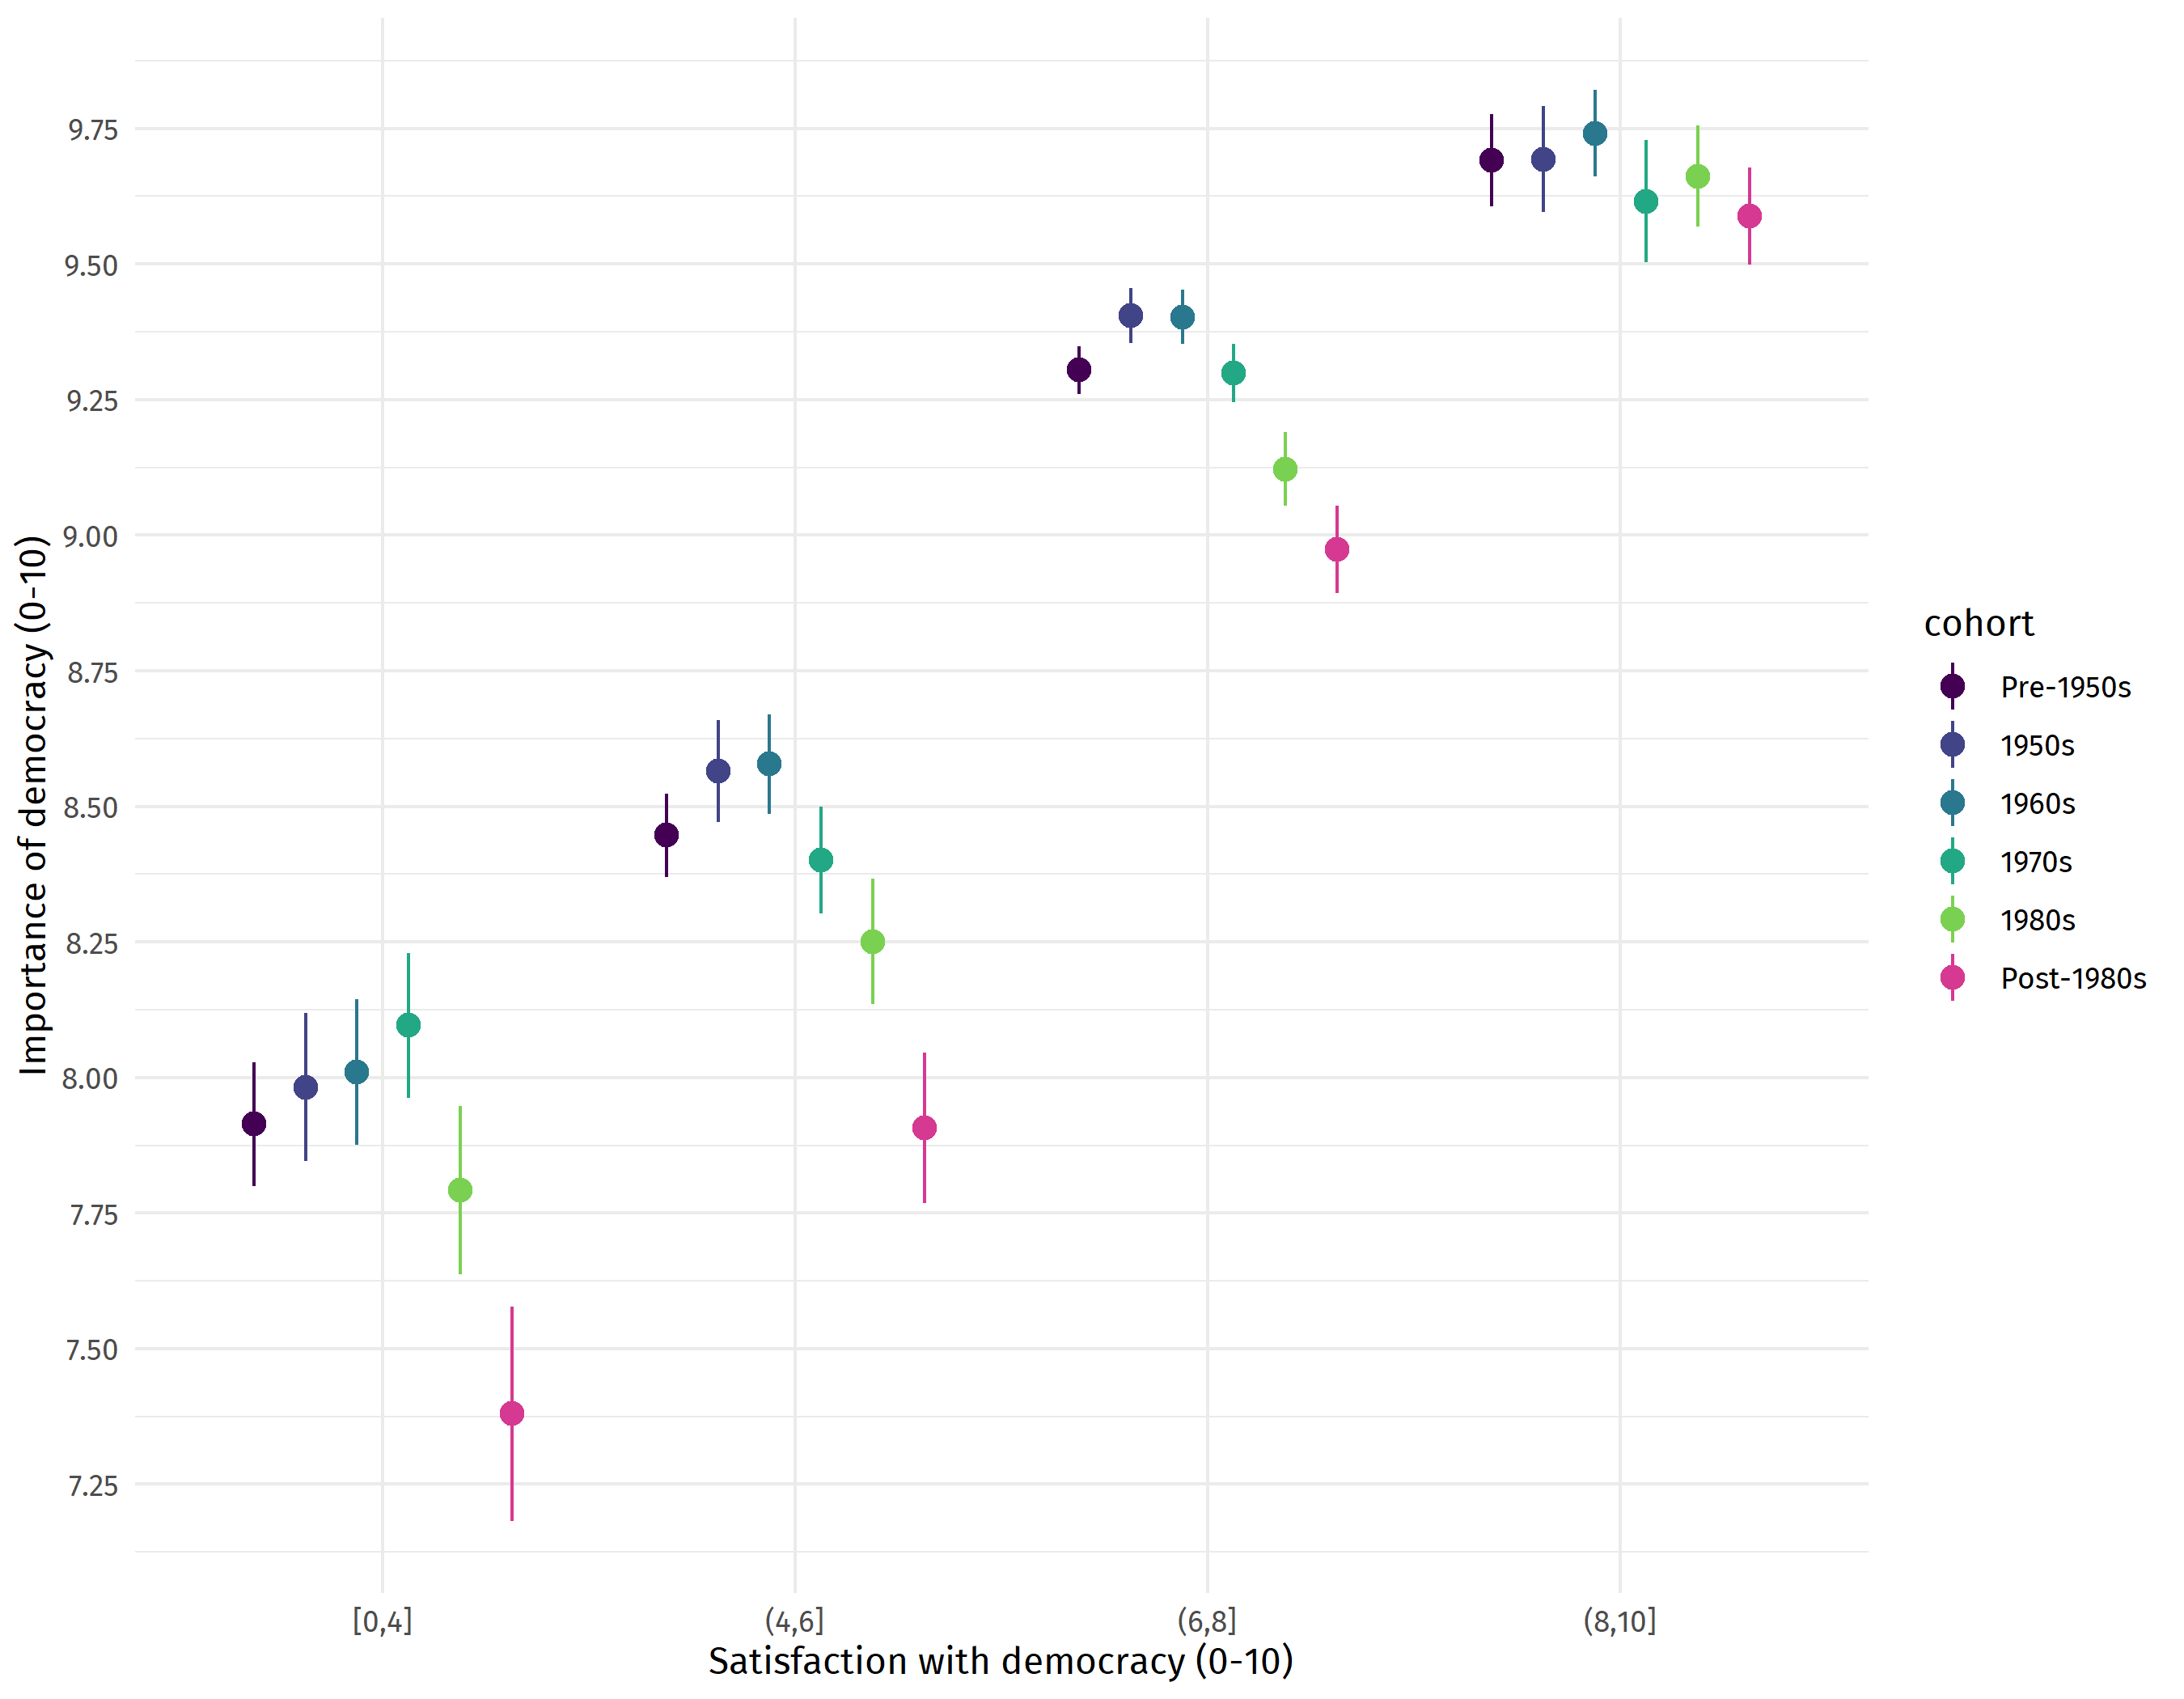

2) No clarity on alternatives Correlations between support for democracy and authoritarian and military and expert are lower for young generations. Olivier to check that.

Also check our own data on this.

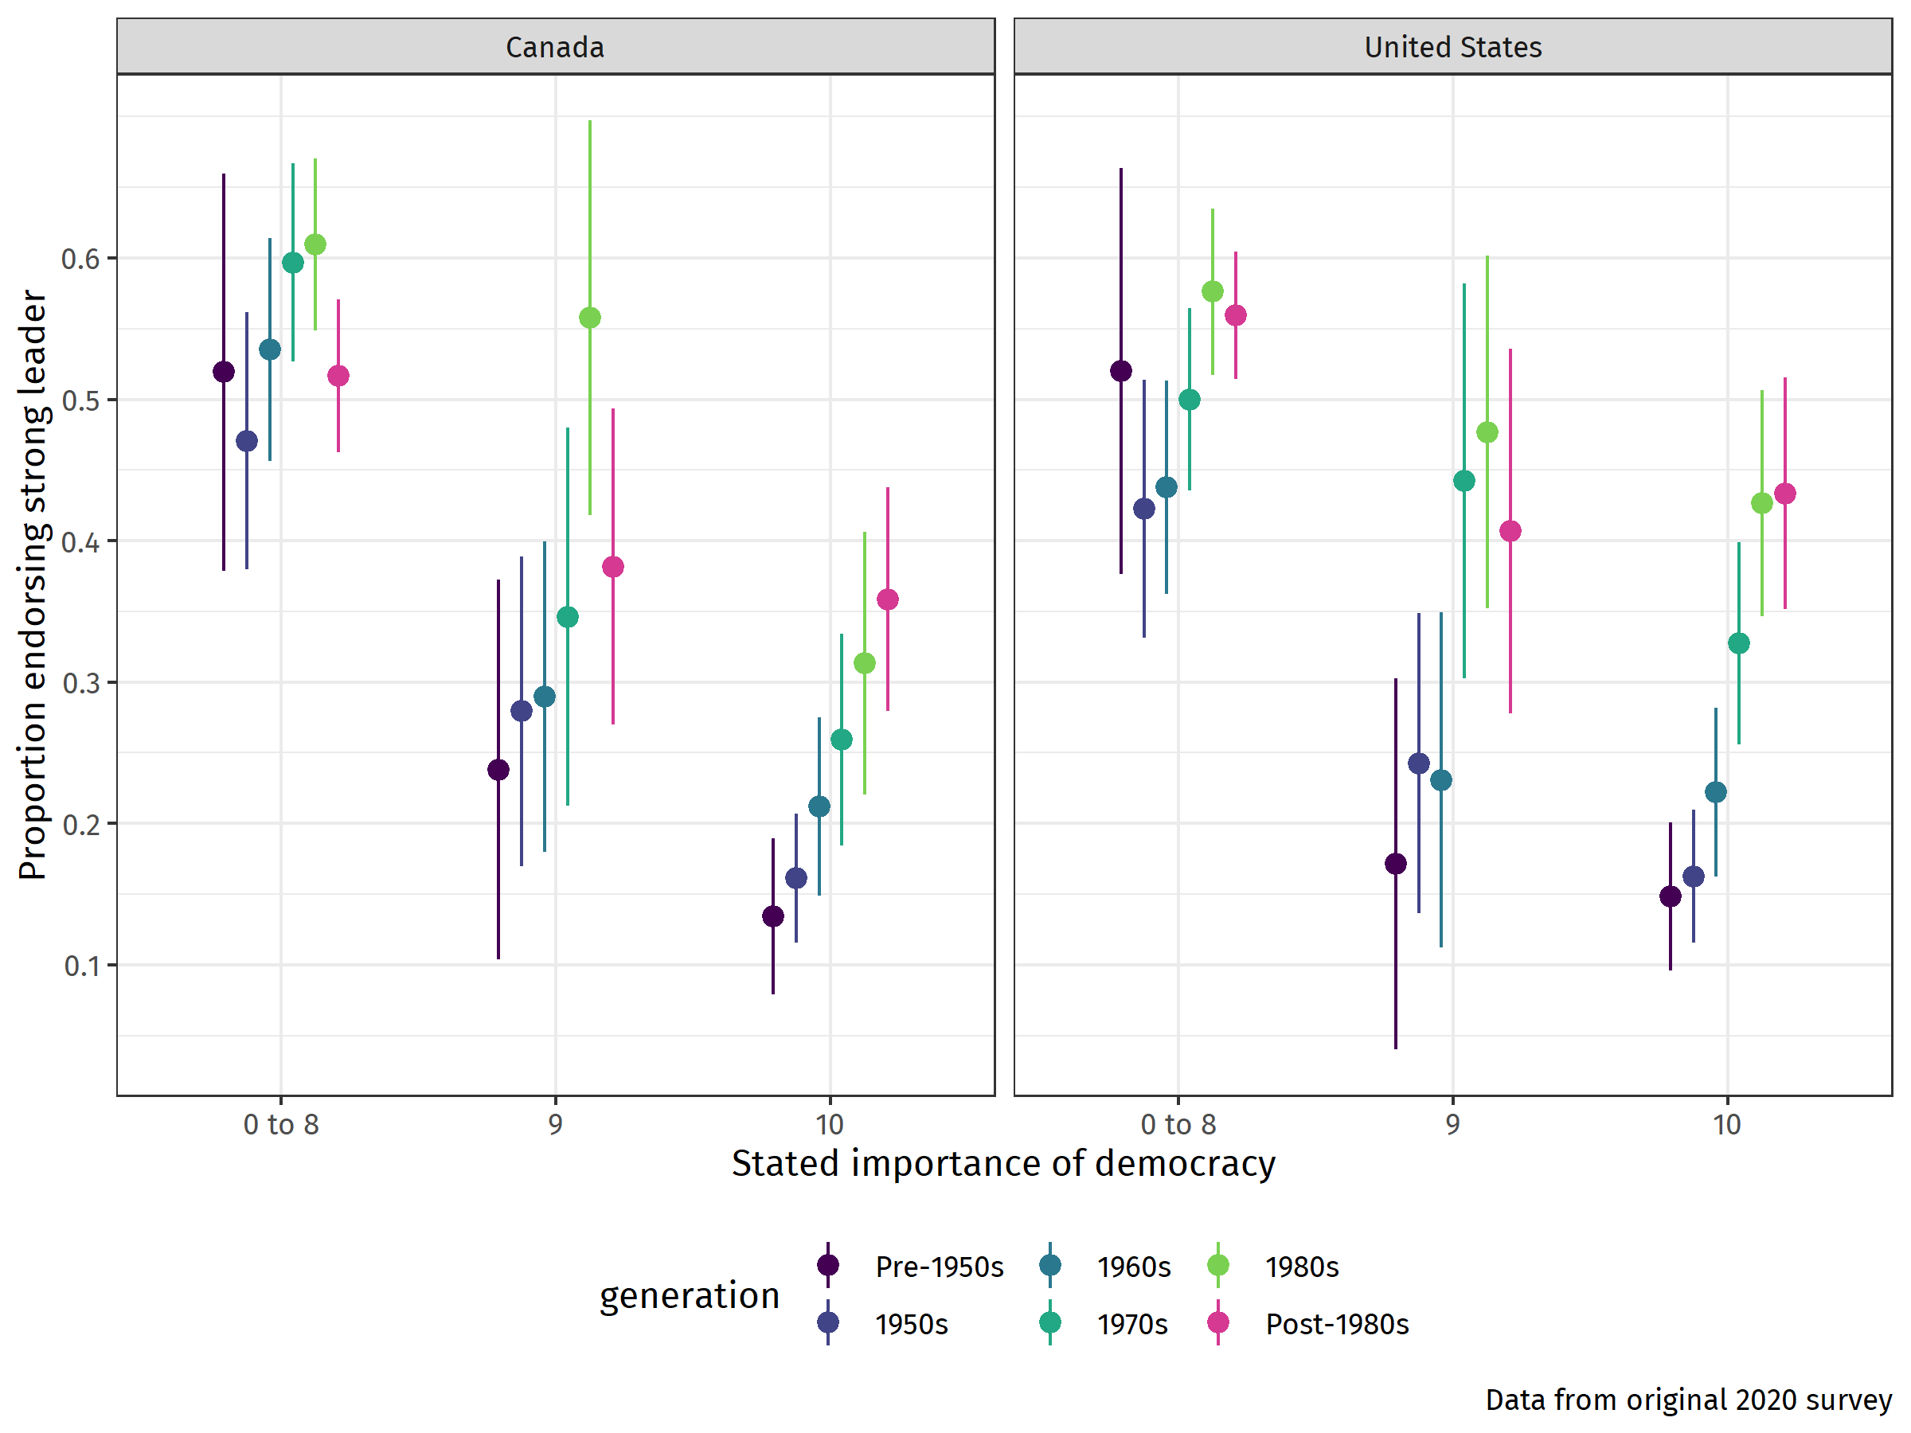

Also, is there a generational pattern to the idea that those who rate democracy of high importance still believe that strong leader/army etc. are good form of government? Is this percentage higher for younger generations?’

This is the same as the beginning graph now but we need it by generation, so I would here graph 2 in this document by generation here, if we indeed keep hypothesis 2, which Elisabeth suggested to merge with 4).

3) Democracy versus actual scenarios: They do not care about the term democracy but actually care and act when democratic scenarios are presented.

--present here small scenarios, battery on democracy versus other goals (climate change), vignette, one conjoint by generation

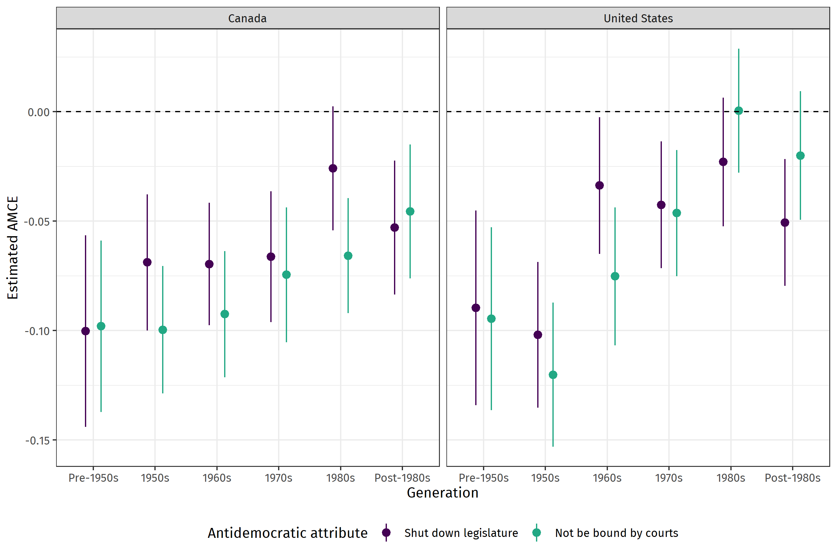

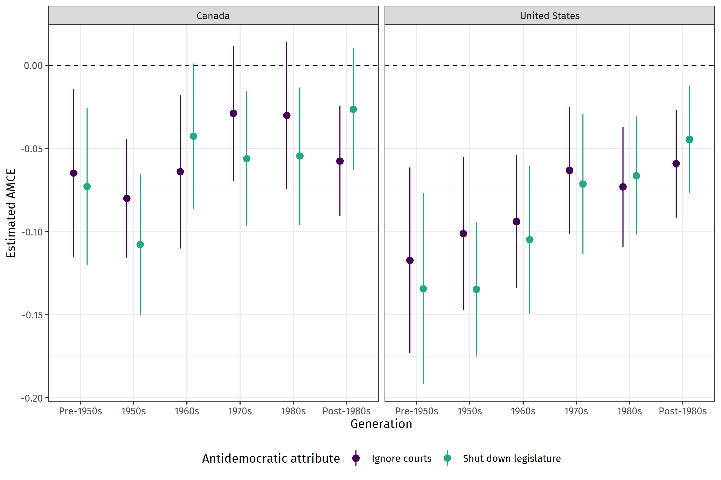

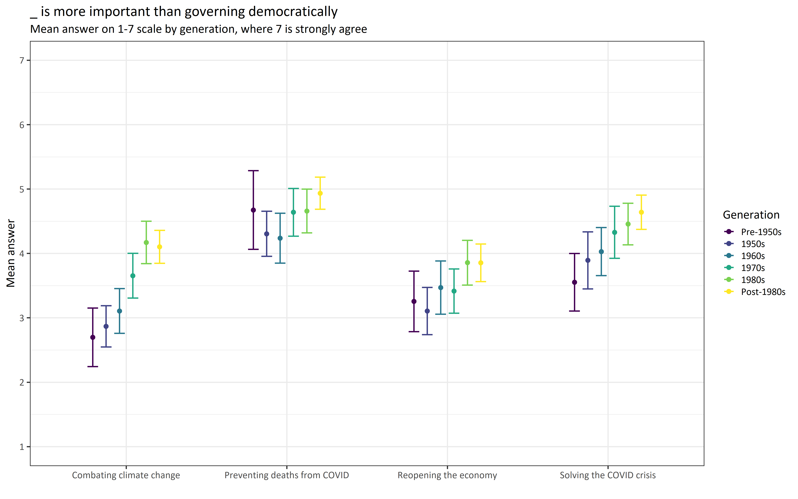

I am missing the vignettes and scenarios here, Olivier. Thee are mega important. We cannot just look at the conjoint and the above question.

4) Democratic Knowledge: They simply do not know about what’s democratic and what’s not (our democratic knowledge battery)

​We have pretty clear evidence that democratic knowledge is lower with younger generations, which we should probably show. We will show one of the following figures made using the 2019 data, which shows vast differences in democratic knowledge across generations in both the US and Canada:

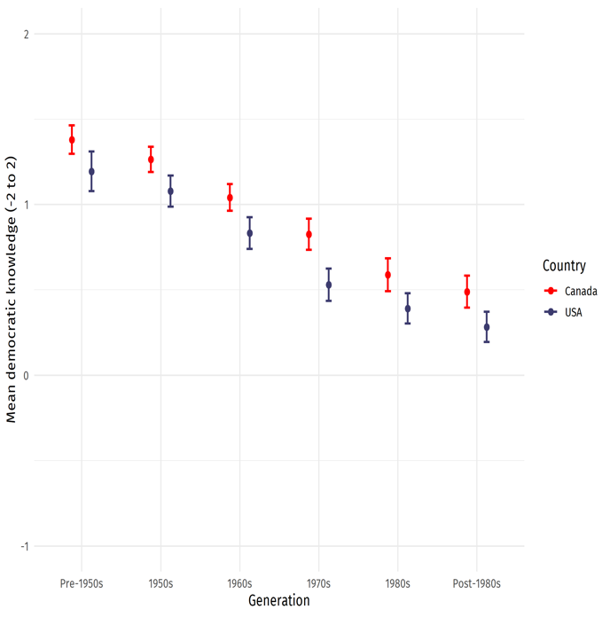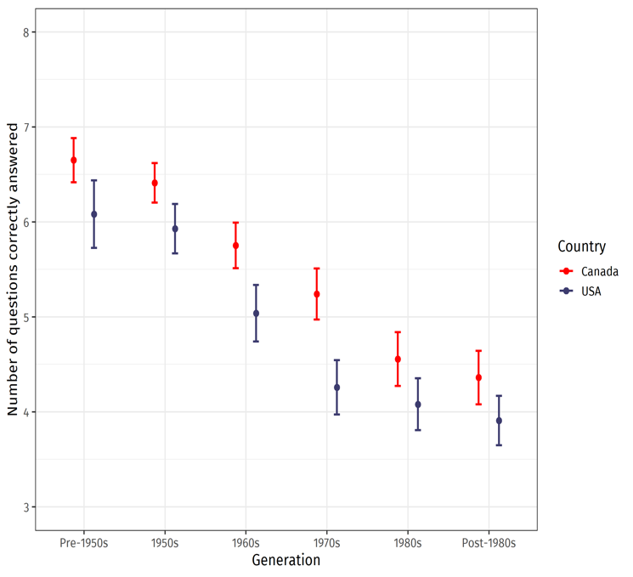

But does including dem knowledge reduce the effects of generations (if we find them)? We then discussed juxtaposing the results for 3 with a control for democratic knowledge to see whether the generational effect disappears. We only do that for those items where we find a generational effect. (one example in Appendix, effect does not completely disappear)

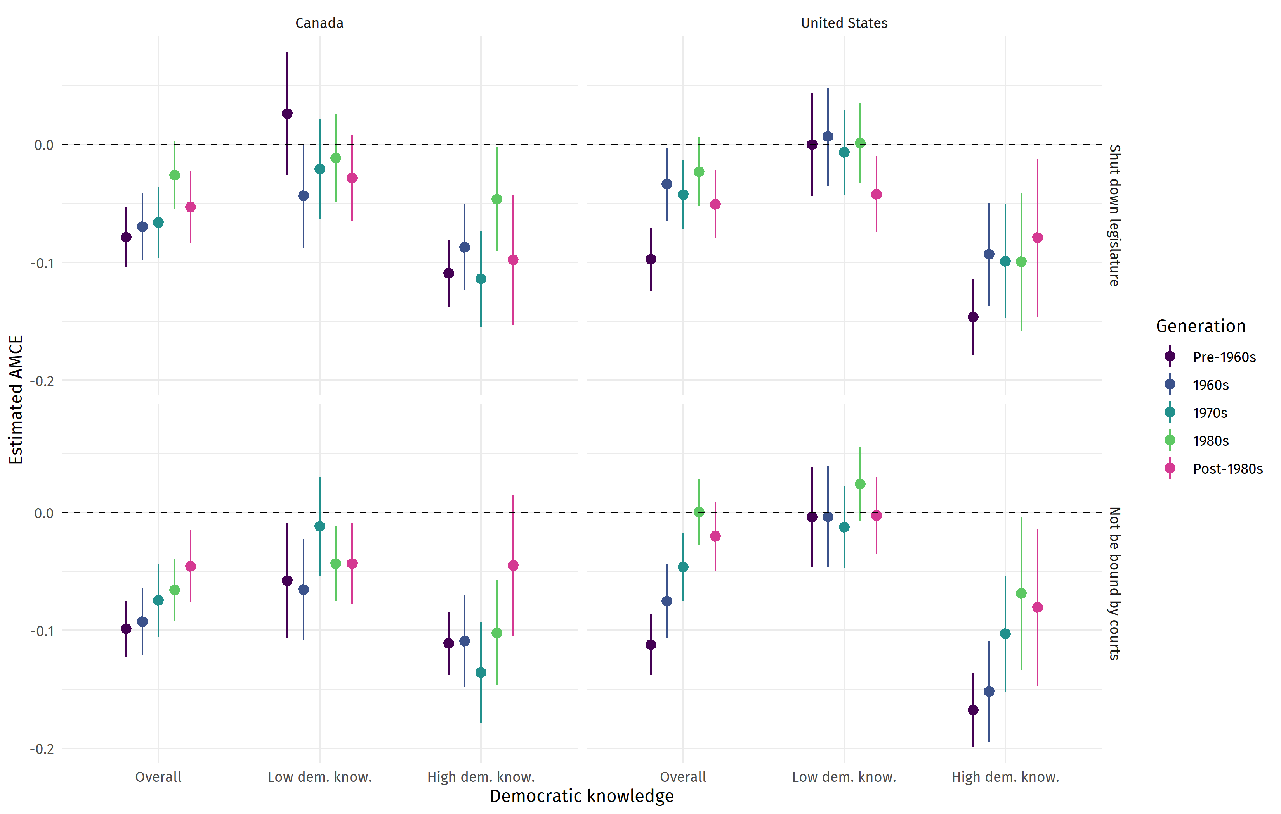

5) Undemocratic young people: They are really undemocratic and want other options, but maybe we do not ask them enough about what they really want or they really want authoritarianism.

Appendix

